**Papers written by Australian Maths Software**

**SEMESTER ONE YEAR 12**

**MATHEMATICS SPECIALIST**

**REVISION 3**

**UNIT 3**

**2016**

**Section One**

**(Calculator–free)**

**Name: _________________________________**

**Teacher: ________________________________**

**TIME ALLOWED FOR THIS SECTION**

Reading time before commencing work: 5 minutes Working time for section: 50 minutes

**MATERIAL REQUIRED / RECOMMENDED FOR THIS SECTION**

**To be provided by the candidate**

Standard items*:* pens, pencils, pencil sharpener, highlighter, eraser, ruler. Special items: nil.

**IMPORTANT NOTE TO CANDIDATES**

No other items may be taken into the examination room. It is **your** responsibility to ensure that you do not have any unauthorised notes or other items of a non–personal nature in the examination room. If you have any unauthorised material with you, hand it to the supervisor **before** reading any further.

**To be provided by the supervisor**

Question/answer booklet for Section One.

A formula sheet which may also be used for Section Two.

MATHEMATICS SPECIALIST Semester One Calculator-free

**Structure of this examination**

|  | Number of  questions  available | Number of  questions to be answered | Working time (minutes) | Marks  available | Percentage of exam |
| --- | --- | --- | --- | --- | --- |
| **Section One**  **Calculator—free** | **5** | **5** | **50** | **50** | **35** |
| Section Two  Calculator—assumed | 12 | 12 | 100 | 100 | 65 |
|  |  |  | Total marks | 150 | 100 |

**Instructions to candidates**

1. The rules for the conduct of this examination are detailed in the Information Handbook. Sitting this examination implies that you agree to abide by these rules.

2. Write your answer in the Question/Answer booklet.

3. You must be careful to confine your responses to the specific questions asked and to follow any instructions that are specific to a particular question.

4. Spare pages are provided at the end of this booklet. If you need to use them, indicate in the original answer space where the answer is continued i.e. give the page number.

5. Show all your working clearly. Your working should be in sufficient detail to allow your answers to be checked readily and for marks to be awarded for reasoning. Incorrect answers given without supporting reasoning cannot be allocated any marks. For any question or part question worth more than two marks, valid working or justification is required to receive full marks. If you repeat an answer to any question, ensure that you cancel the answer you do not wish to have marked.

6. It is recommended that you **do not use pencil**, except in diagrams. 7. The Formula Sheet is **not** to be handed in with your Question/Answer booklet.

___________________________________________________________________________ 2

MATHEMATICS SPECIALIST Semester One Calculator-free

1. (6 marks)

(a) The graph of is drawn for on the set of axes below. *y* = *f* ( *x*) *x* > 0 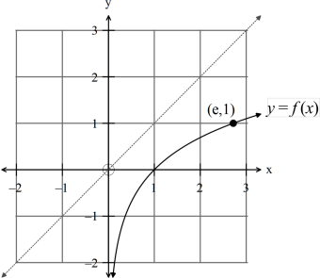

(i) Sketch the inverse function . (1) ( )

−1

*y* = *f x*

(ii) Write down the equation of both functions, and . (2) *y* = *f* ( *x*) ()−1 *y*=*f x*

(iii) Write down the domain and the range of ( )

−1

*y* = *f x* . (2)

(iv) Given , find (1) ( ) *f e* = 2 ( )

2

−

1 2

*f .*

___________________________________________________________________________ 3

MATHEMATICS SPECIALIST Semester One Calculator-free

2. (10 marks)

Matrices can be used to solve systems of equations such as

*a x b y c z d*

+ + =

1 1 1 1

*a x b y c z d*

+ + =

2 2 2 2

*a x b y c z d*

+ + =

3 3 3 3

where each equation represents a plane in space.

Solve each the following where possible and interpret the result.

⎛ ⎞

2 0 0 2

⎜ ⎟

0 5 0 10

(a) (1) − ⎝ ⎠

0 0 1 3

⎛ − ⎞

1 2 1 3

⎜ ⎟

0 2 0 1

(b) (2) 0 0 0 2

⎝ ⎠

⎛ − − ⎞

1 2 5 2

⎜ ⎟

0 1 3 6

(c) (2) 0 0 0 0

⎝ ⎠

___________________________________________________________________________ 4

MATHEMATICS SPECIALIST Semester One Calculator-free

(d) Use Gaussian elimination to solve the set of equations

*x y z*

+ + =

0

2 2 6

*x y z*

− + = −

(5)

2 2 5

*x y z*

− + = −

___________________________________________________________________________ 5

MATHEMATICS SPECIALIST Semester One Calculator-free

3. (8 marks)

( )

*x*

−

1

(a) Given the sketch of the function ( ~~)~~ *f ~~x~~*

=−

( )

*x x*

2

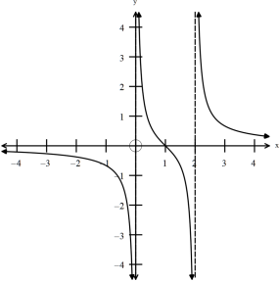

find the equations of the graphs below.

(i) (2)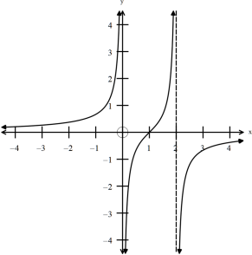

___________________________________________________________________________ 6

MATHEMATICS SPECIALIST Semester One Calculator-free

(ii) (3) 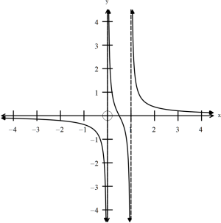

(iii) (3)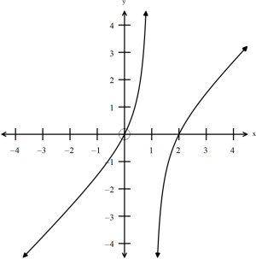

___________________________________________________________________________ 7

MATHEMATICS SPECIALIST Semester One Calculator-free

4. (13 marks)

(a) Given find the values of if the roots of the 3 2

*z* + *az* + *bz* + *c* = 0***,*** *a****,*** *b* and *c* equation are (3) 4 and 1± 2*i****.***

(b) Given one solution to the equation is , find the other 3 2

*z* + 2*z* + 2*z* +1 = 0 z =−1

two solutions. (4)

___________________________________________________________________________ 8

MATHEMATICS SPECIALIST Semester One Calculator-free

(c) (i) Determine the solutions of the equation for . (3) 3 *z* = −8 −π<θ≤π

(ii) Explain the relationship between the roots. (1)

(iii) Illustrate the roots on the diagram below. (2)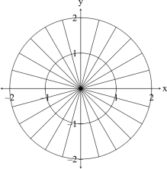

___________________________________________________________________________ 9

MATHEMATICS SPECIALIST Semester One Calculator-free

5. (13 marks)

4 2 − 2*i*

(a) Simplify (1) ( )

(b) Express with a rational denominator (3) 3 2 1

− +

*i i*

− ~~+~~

3 1

+ −

*i i i*

(c) Find real numbers such that . (2) *x* and *y* (2 + 3*i*)(3− 4*i*) =*x* +*yi.*

___________________________________________________________________________ 10

MATHEMATICS SPECIALIST Semester One Calculator-free (d) Sketch ( ~~)~~ on the set of axes below. (2) 3

⎧ π π⎫ ⎨ < ~~− + ≤ ∩ − < ≤~~ ⎬

*z ~~: z i~~ arg ~~z~~*

1 ~~1 2~~

4 4

⎩ ⎭ 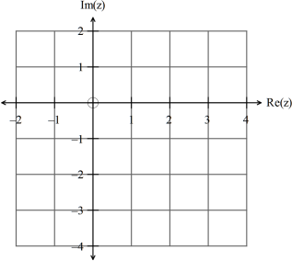

(e) Sketch on the set of axes below. (2) 1 2 1 2 *z* − *z* given *z* = 3+ 2*i* and *z* = 3*i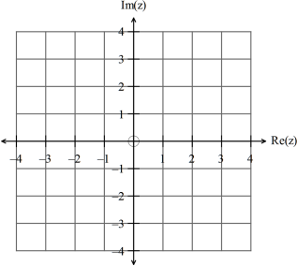*

___________________________________________________________________________ 11

MATHEMATICS SPECIALIST Semester One Calculator-free

⎛ π ⎞ ⎛ π ⎞ = ⎜ ~~⎟~~ = ⎜ ⎟ = − (f) If 1 2 3 1 ⎝ ⎠ ⎝ ⎠ *z ~~cis , z cis~~ z i*

and

4 3

4

evaluate (3) ( ) *zz . z*

1

×

3 3

( )

2

**END OF SECTION ONE**

___________________________________________________________________________ 12